**DAILY ONLINE ACTIVITIES SUMMARY**

|  |  |  |  |  |  |  |  |
| --- | --- | --- | --- | --- | --- | --- | --- |
| **Date:** | **07-06-2020** | | | | **Name:** | **RAVALI P** | |
| **Sem & Sec** | **6 B** | | | | **USN:** | **4AL17CS076** | |
| Online Test Summary | | | | | | | |
| **Subject** | | **SSCD** | | | | | |
| **Max. Marks** | | **30** | | **Score** | | **24** | |
| Certification Course Summary | | | | | | | |
| **Course** | **HTML AND CSS LEARNING** | | | | | | |
| **Certificate Provider** | | | **UDEMY** | **Duration** | | | **2 DAYS** |
| Coding Challenges | | | | | | | |
| **Problem Statement-ONE PYTHON PROGRAM AND ONE JAVA PROGRAM.** | | | | | | | |
| **Status:Executed** | | | | | | | |
| **Uploaded the report in Github** | | | | **Yes** | | | |
| **If yes Repository name** | | | | **https://github.com/Ravalipr/Daily-Status.git** | | | |
| **Uploaded the report in slack** | | | | **Yes** | | | |

Online Test Details: (Attach the snapshot and briefly write the report for the same)

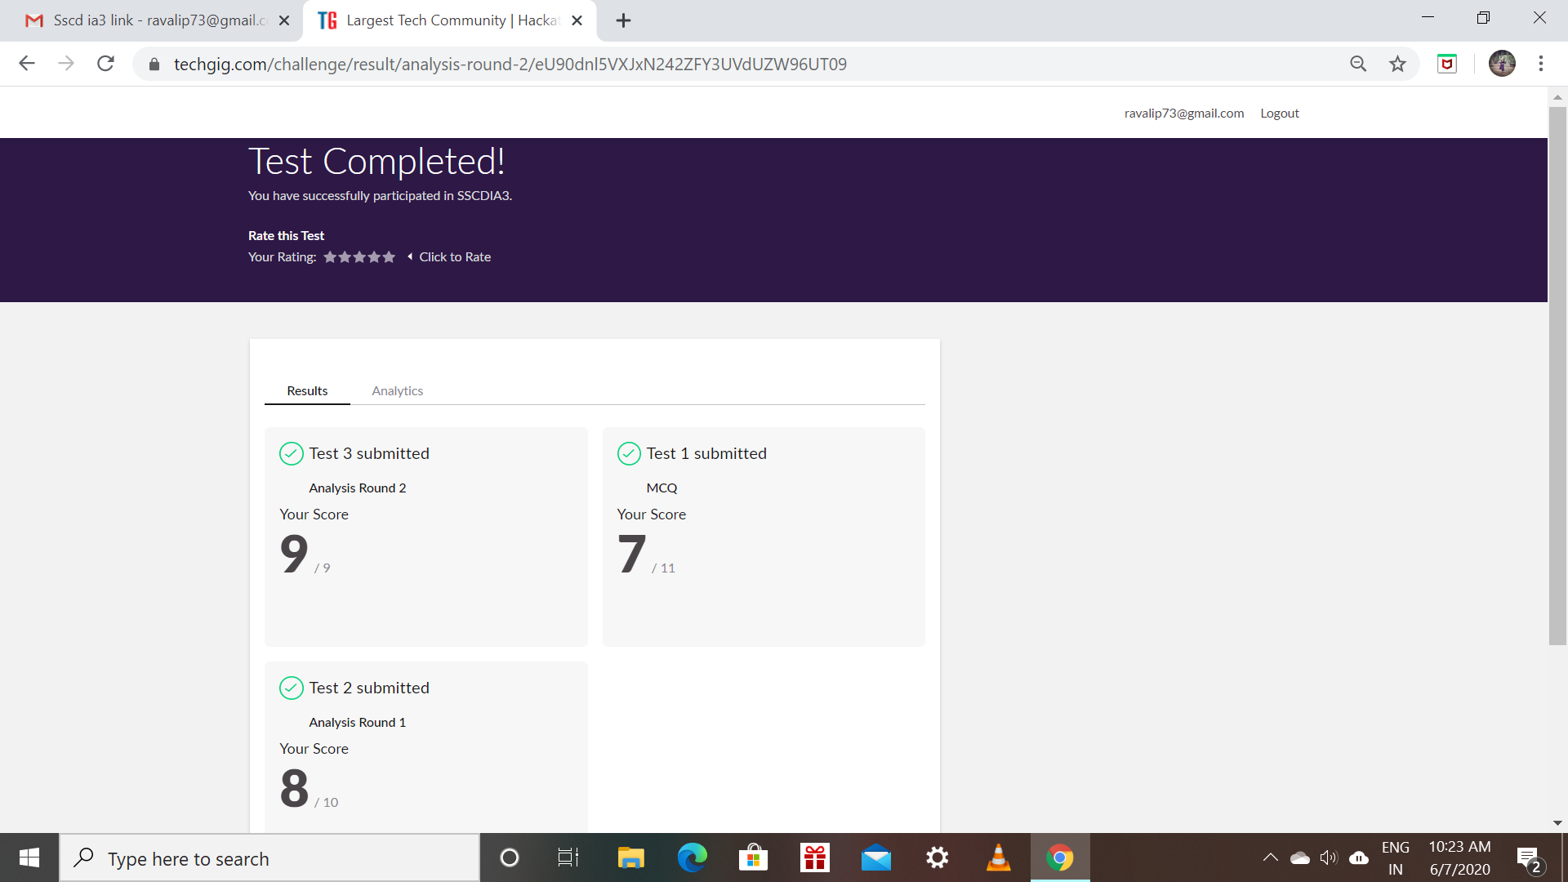

Certification Course Details: (Attach the snapshot and briefly write the report for the same)

* Todays topic is about learning the basic html tags and how to apply them to create a website.
* The lecture also contains about the css and the various body styles we need to include in our code.
* How to create a simple background with including buttons to navigate.

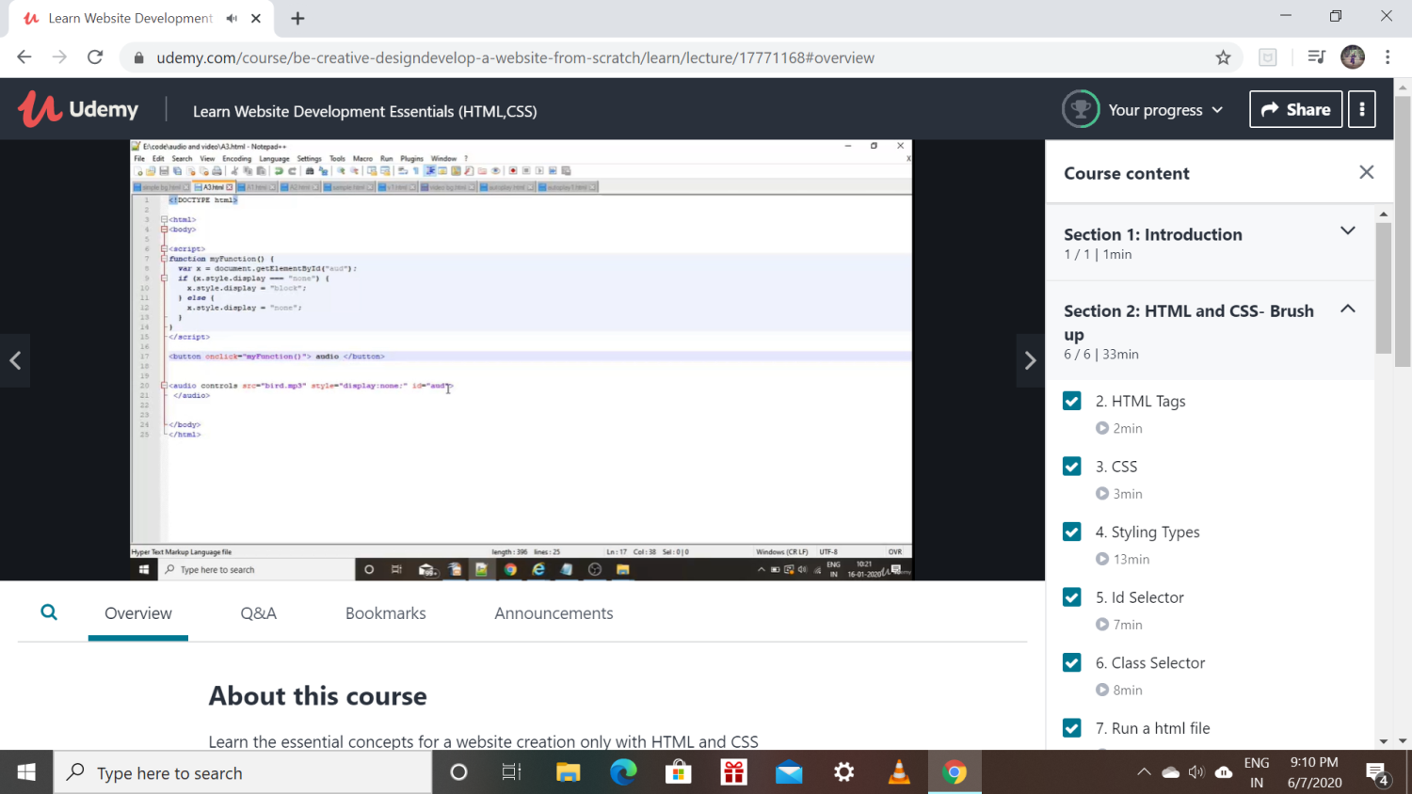

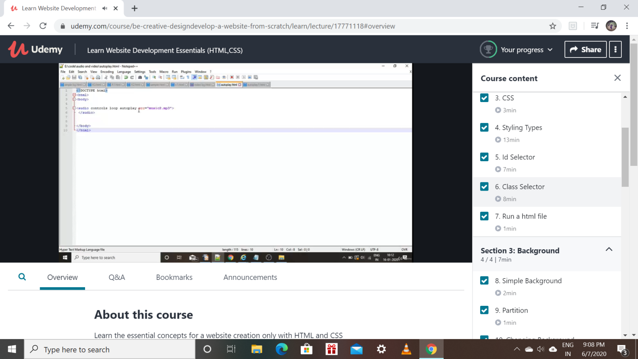

Coding Challenges Details: (Attach the snapshot and briefly write the report for the same)

Program1:

write a java Program to print smallest and biggest possible palindrome word in a given string.

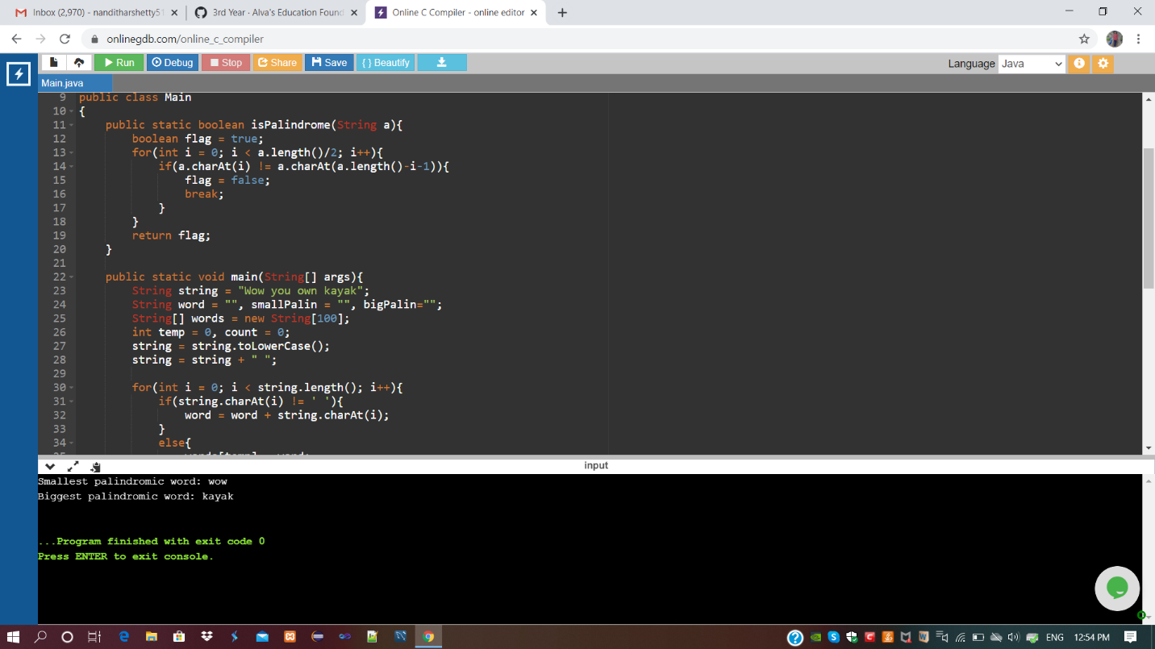

Program 2:

Python program to Print a list of first and last 5 elements where the values are square of numbers between 1 and 30 (both included).

